

***Human Biology ATAR – Task 2:* End of term test**

***Content covered weeks 9-12 (6%)***

|  |  |  |  |
| --- | --- | --- | --- |
| Name: | | | |
| Time allowed: 55 Minutes + 5 minutes reading time | | | |
| **Section** | Your Mark | Marks available | Percentage of Investigation |
| **Multiple Choice (A)** |  | 15 | 25% |
| **Short Answer (B)** |  | 35 | 58% |
| **Extended Response (C)** |  | 10 | 17% |
|  |  | **60** | **100%** |

**Declaration of Authenticity**

I (Student Name) _____________________ declare that this work is my own and I have not plagiarised from any source.

Signature:  
  
Date:

***Section A – Multiple Choice (15 marks)***

*Answer all questions by clearly circling the letter ONLY. Use only a BLUE or BLACK pen. If you make a mistake, place a CROSS through the letter; do not erase or use correction fluid, and circle your new answer. Marks will not be deducted for incorrect answers. No marks will be given if more than one answer is completed for any question*

1. The series of muscular contractions that moves food along the digestive tract is called
   1. Periosteum
   2. Peristalsis
   3. Pericardium
   4. Perimysium
2. Urine is stored in the:
   1. Kidney
   2. Bladder
   3. Urethra
   4. Ureter
3. The flap of tissue that covers the trachea during swallowing is called the:
   1. Glottis
   2. Epiglottis
   3. Peristalsis
   4. Larynx
4. The process of deamination occurs in the:
5. Kidney
6. Pancreas
7. Stomach
8. Liver
9. The projections found along the walls of the small intestine are called:
10. Mucosa
11. Villi
12. Rennin
13. Ileum
14. Which of the following reactions is catalyzed by lipase?
    1. Starch to maltose
    2. Fats to fatty acids
    3. Polypeptides to amino acids
    4. Fatty acids to micelles
15. Absorption of digested food occurs largely in the:
16. Small intestine
17. Pancreas
18. Stomach
19. Large intestine
20. Bile is involved in the breakdown of fats. It is:
21. Produced in the gall bladder and stored in the liver
22. Produced in the liver and stored in the gall bladder
23. Produced in the pancreas and stored in the liver
24. Produced and stored in the liver
25. In the sliding filament theory of muscle contraction which of the following occurs:
    1. The I bands lengthen
    2. The actin filaments slide past the myosin filaments
    3. The Z lines move further apart
    4. The A band shortens
26. The vertebral column, rib cage and skull form the:
    1. Axial skeleton
    2. Appendicular skeleton
    3. Pectoral girdle
    4. Pelvic girdle
27. The shaft of a long bone is called the:
    1. Periosteum
    2. Trabuculae
    3. Diaphysis
    4. Epiphysis
28. Any movement away from the midline of the body is termed?
29. Rotation
30. Abduction
31. Flexion
32. Adduction

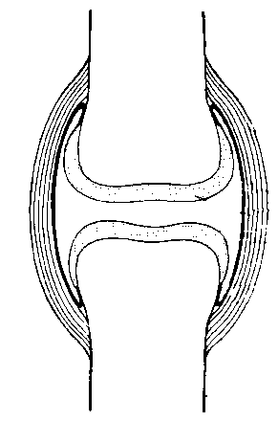

1. This type of joint illustrated above is a
   1. Pivot joint
   2. Ball and socket joint
   3. Synovial joint
   4. Articulated joint
2. In order to bend the arm at the elbow the biceps muscle must contract. At the same time the triceps muscle must?
   1. Relax
   2. Shorten
   3. Push on the ulna
   4. Pull on the radius
3. The joint between two vertebrae is an example of a?
   1. Fixed Joint
   2. Hinge joint
   3. Slightly moveable joint
   4. Pivot joint

**END OF MULTIPLE CHOICE**

***Section B – Short Answer***

Answer all questions in the spaces provided. Use only BLUE or BLACK pen.

1. Name a part of the alimentary canal that is involved in (4 marks)
2. Secretion of enzymes

**MOUTH / SALIVA, STOMACH, SMALL INTESTINE (PITS), PANCREAS**

1. Absorption of nutrients

**SMALL INTESTINE, LARGE INTESTINE (VITAMINS/NUTRIENTS)**

1. Peristalsis

**OESOPHAGUS, LARGE INTESTINE, SMALL INTESTINE**

1. Defecation

**RECTUM (STORED), PUSHED THROUGH ANUS**

1. The diagram below shows a single villus

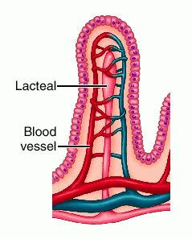

**(iii)**

**(i)**

**(ii)**

1. Label the following parts (3 marks)

(i) **LACTEAL**

(ii) **CAPILLARY**

(iii) **MICROVILLI/Epithelium**

1. Where are villi found in the digestive system? (1 mark)

**SMALL INTESTINE – WALLS OF – ALL ALONG THE LENGTH**

1. Why are the villi so small and so numerous? (1 mark)

**TO INCREASE SURFACE AREA FOR ABSORPTION TO OCCUR**

1. Use the diagram of a kidney to fill in the missing labels (5 marks)

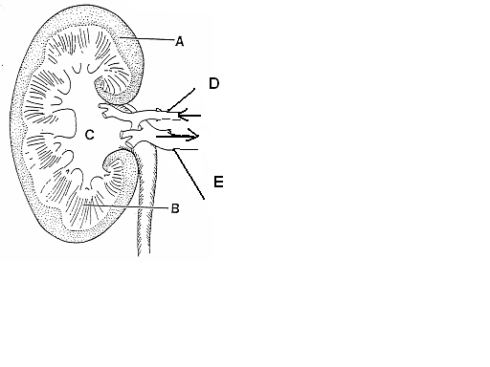

A  **CORTEX**

B  **MEDULLA/RENAL PRYAMID**

C **PELVIS**

D  **RENAL ARTERY**

E  **RENAL VEIN**

1. What is the name of the structure that INITIALLY filters the blood in the kidney? (1 mark)

**BOWMAN’S CAPSULE / GLOMERULAR CAPSULE**

1. The tube leading from the bladder to the outside is called? (1 mark)

**URETHRA**

1. What happens to the urine output if the body fluids contain less water? (1 mark)

**DECREASES**

1. Label the attachments marked A to F on the diagram below (6 marks)

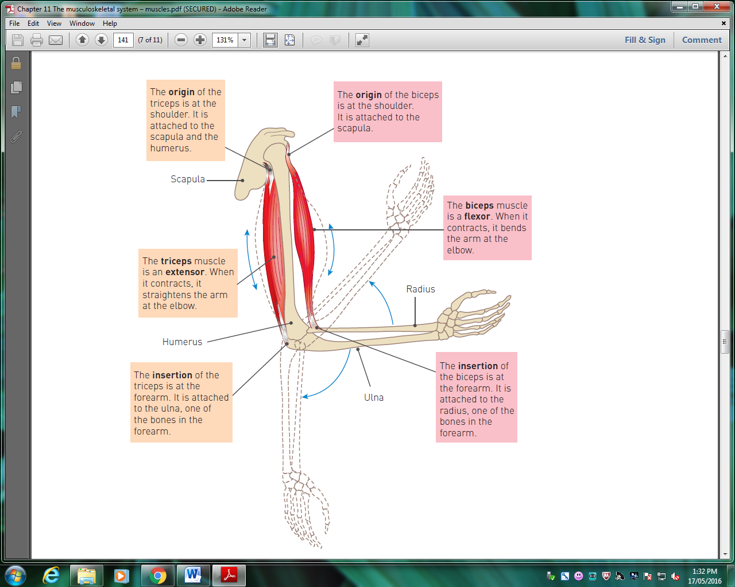

C- origin biceps

D- origin triceps

B- biceps muscle

E- triceps muscle

A-Insertion biceps

F- insertion triceps

1. B and E are antagonistic muscles. Explain how these two muscles work together to cause

(4 marks)

(i) Flexion

B-BICEPS - contracts - bends the arm

(ii) Extension

E – TRICEPS – Contracts – extending the arm

1. The following diagram illustrates the structure of a knee joint.

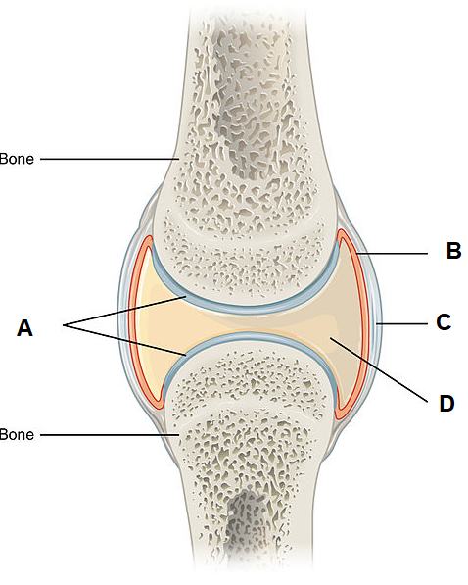

1. State the name given to this type of joint in the body (1 mark)

Synovial joint / hinge joint

1. Briefly describe how the structures labelled B and D prevent injury to these types of joints (3 marks)

Structure B/synovial membrane produces structure D/synovial fluid

Cushions the joint (against impact)

Reduces friction

Lubricates the joint

Prevents moving surfaces from touching each other

1. Complete the table below to identify the specific type of joint illustrated and provide **one** location for each (4 marks)

|  |  |  |
| --- | --- | --- |
|  |  |  |
| Type of joint: | Saddle | Hinge |
| Location of joint: | Thumb | Elbow/knee/ankle/  fingers/toes |

***Section C – Extended Response***

*Write your answer on the lined pages provided. Answers should be in BLUE or BLACK pen*

1. The formation of urine by the nephron of the kidneys involves three major processes; ***filtration***, ***reabsorption*** and ***secretion*** in the tubules. Explain each of these processes in detail (10 marks)

**Filtration:**

* Occurs at the renal corpuscle
* Blood is transported in through the afferent arteriole
* The efferent arteriole has a smaller diameter which leads to pressure build up in the glomerulus
* This high pressure pushes out most of the substances from the blood into the tubule/glomerular capsule
* This fluid is referred to as filtrate
* It contains everything except red and white blood cells and large proteins which cannot transfer out of the arteriole OR it contains (states at least 4) water, salts, amino acids, fatty acids, glucose, urea, uric acid, creatinine, hormones, toxins and various ions.

**Reabsorption:**

* Selective reabsorption involves reabsorbing substances from the filtrate back into the blood vessels that are useful for the body
* Reabsorb (lists at least 3) water, glucose, amino acids and ions (e.g. sodium potassium), bicarbonate
* Water reabsorption occurs through simple diffusion in the proximal convoluted tubule, and descending loop of Henle.
* Water reabsorption also occurs through facultative reabsorption which is controlled hormonally at the distal convoluted tubule and collecting duct.

**Secretion:**

* Involves adding substances from the blood into the tubule.
* Substances secreted into the tubule are (lists at least 3) potassium, hydrogen, ammonium, urea, uric acid, creatinine and some drugs